PRIVATE CONSULTATION FEES
(From 1/3/2018)
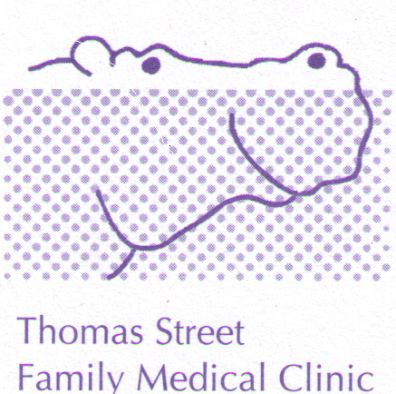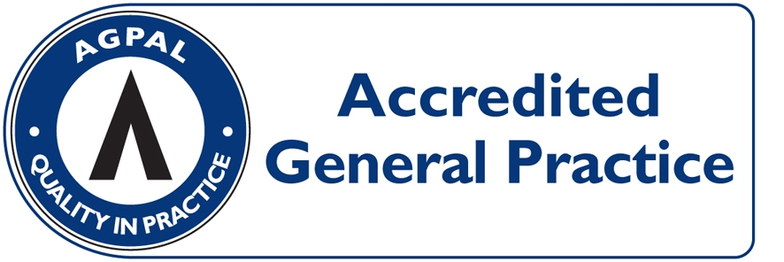
CONSULTATION | PAY ON DAY | MEDICARE REBATE  (01/10/2016) | OUT OF POCKET
LEVEL B  (STANDARD, ie 5 to 20 minutes) | $73.00 | $37.05 | $35.95
LEVEL C  (LONG, i.e. more than 20 minutes) | $111.00 | $71.70 | $39.95
LEVEL D  (PROLONGED, i.e. more than 40 minutes) | $160.00 | $105.55 | $54.45
ACUPUNCTURE  (Acupuncture + Consultation $67) | $73.00 | $37.05 | $35.95
HOME VISIT  (STANDARD) | $144.00 | $63.00 | $81.00

HEALTH CARE CARD HOLDERS: LEVEL B = $53.00 OUT OF POCKET $15.95
(INCLUDING PENSIONERS) LEVEL C = $88.00 OUT OF POCKET $16.30
ACCOUNT FEE: $20 IF NOT PAYING ON DAY

SATURDAYS: $5 Surcharge. SUNDAYS/PUBLIC HOLIDAYS: Fees set out separately.

PROCEDURES: (EG, MOLE REMOVAL) $60 OUT OF POCKET EXPENSE

CONSULTATIONS LONGER THAN 45 MINUTES AND HYPNOTHERAPY: OUT OF POCKET COSTS FROM $60.00 DEPENDING ON THE LENGH OF THE CONSULTATION (FULL FEE LIST AVAILABLE FROM RECEPTION).

REDUCED FEES: ($5 DISCOUNT) FOR SHARED ANTENATAL CARE VISITS AND ALLERGY DESENSITISATION INJECTIONS.

CHILDHOOD VACCINATIONS: BULK-BILLED

PAYMENT OPTIONS: VISA/MASTER CARD/EFTPOS/ CASH/ CHEQUE. SORRY NO DINERS CARD OR AMEX FACILITIES

