PRIVATE CONSULTATION FEES
(From 1/04/2019)
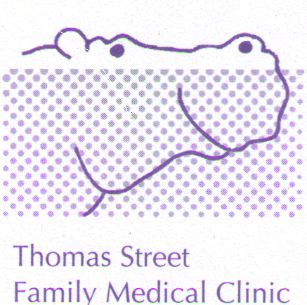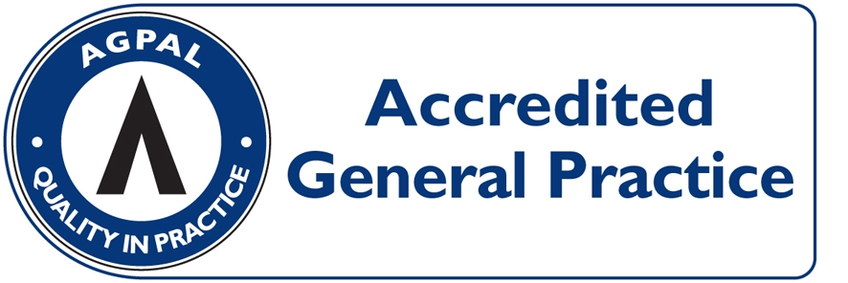
CONSULTATION | PAY ON DAY | MEDICARE REBATE  (01/10/2016) | OUT OF POCKET
LEVEL B  (STANDARD, ie 5 to 20 minutes) | $76.00 | $37.60 | $38.40
LEVEL C  (LONG, i.e. more than 20 minutes) | $111.00 | $72.80 | $38.20
LEVEL D  (PROLONGED, i.e. more than 40 minutes) | $160.00 | $107.15 | $52.85
ACUPUNCTURE  (Acupuncture + Consultation $67) | $73.00 | $37.05 | $35.95
HOME VISIT  (STANDARD) | $144.00 | $63.95 | $80.05

HEALTH CARE CARD HOLDERS: LEVEL B = $53.00 OUT OF POCKET $15.40
(INCLUDING PENSIONERS) LEVEL C = $88.00 OUT OF POCKET $15.20
ACCOUNT FEE: $20 IF NOT PAYING ON DAY

SUNDAYS/PUBLIC HOLIDAYS: $5 Surcharge SATURDAYS: $5 Surcharge

PROCEDURES: (EG, MOLE REMOVAL) $60 OUT OF POCKET EXPENSE

CONSULTATIONS LONGER THAN 45 MINUTES AND HYPNOTHERAPY: OUT OF POCKET COSTS FROM $60.00 DEPENDING ON THE LENGH OF THE CONSULTATION (FULL FEE LIST AVAILABLE FROM RECEPTION).

REDUCED FEES: ($5 DISCOUNT) FOR SHARED ANTENATAL CARE VISITS AND ALLERGY DESENSITISATION INJECTIONS.

CHILDHOOD VACCINATIONS: BULK-BILLED

PAYMENT OPTIONS: VISA/MASTER CARD/EFTPOS/ CASH/ CHEQUE. SORRY NO DINERS CARD OR AMEX FACILITIES

