PRIVATE CONSULTATION FEES
(From 1/08/2021)
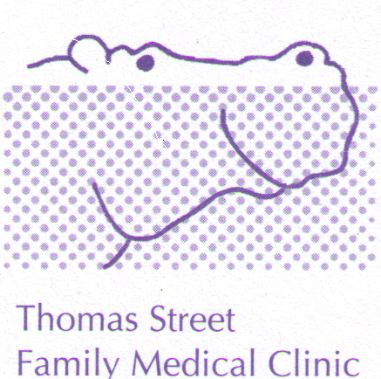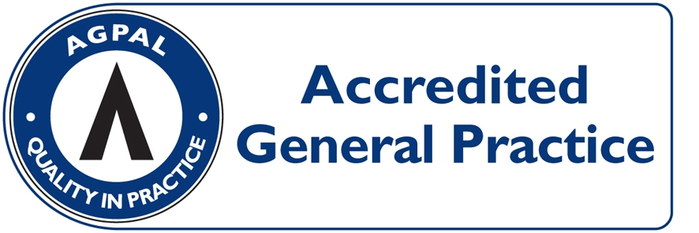
CONSULTATION | PAY ON DAY | MEDICARE REBATE  (01/07/2021) | OUT OF POCKET
LEVEL B  (STANDARD, ie 5 to 20 minutes) | $80.00 | $39.10 | $40.90
LEVEL C  (LONG, i.e. more than 20 minutes) | $118.00 | $75.75 | $42.25
LEVEL D  (PROLONGED, i.e. more than 40 minutes) | $168.00 | $111.50 | $56.50
ACUPUNCTURE  (Acupuncture + Consultation $67) | $75.00 | $38.55 | $36.45
HOME VISIT  (STANDARD) | $146.00 | $66.50 | $79.50

HEALTH CARE CARD HOLDERS: LEVEL B = $54.00 OUT OF POCKET $14.90
(INCLUDING PENSIONERS) LEVEL C = $91.00 OUT OF POCKET $15.25

ACCOUNT FEE: $20 - IF NOT PAYING ON DAY

PROCEDURES: (EG, MOLE REMOVAL) $60 OUT OF POCKET EXPENSE

CONSULTATIONS LONGER THAN 45 MINUTES AND HYPNOTHERAPY: OUT OF POCKET COSTS FROM $60.00 DEPENDING ON THE LENGH OF THE CONSULTATION (FULL FEE LIST AVAILABLE FROM RECEPTION).

CHILDHOOD VACCINATIONS: BULK-BILLED

PAYMENT OPTIONS: VISA/MASTER CARD/EFTPOS/ CASH/ CHEQUE. SORRY NO DINERS CARD OR AMEX FACILITIES

