PRIVATE CONSULTATION FEES
(From 1/08/2022)
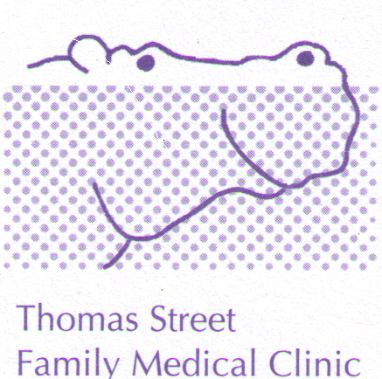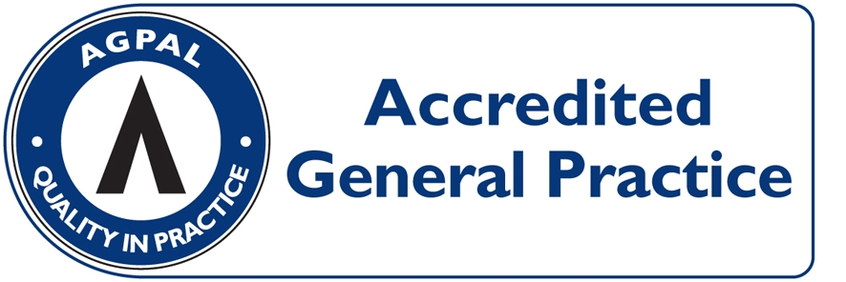
CONSULTATION | PAY ON DAY | MEDICARE REBATE  (01/07/2022) | OUT OF POCKET
LEVEL B  (STANDARD, ie 5 to 20 minutes) | $90.00 | $39.75 | $50.25
LEVEL C  (LONG, i.e. more than 20 minutes) | $130.00 | $76.95 | $53.05
LEVEL D  (PROLONGED, i.e. more than 40 minutes) | $180.00 | $113.30 | $66.70
ACUPUNCTURE  (Acupuncture + Consultation $67) | $85.00 | $39.15 | $45.85
HOME VISIT  (STANDARD) | $156.00 | $67.60 | $88.40

HEALTH CARE CARD HOLDERS: LEVEL B = $60.00 OUT OF POCKET $20.25
(INCLUDING PENSIONERS) LEVEL C = $98.00 OUT OF POCKET $21.05

ACCOUNT FEE: $20 - IF NOT PAYING ON DAY

PROCEDURES: (EG, MOLE REMOVAL) $70 OUT OF POCKET EXPENSE

CONSULTATIONS LONGER THAN 45 MINUTES AND HYPNOTHERAPY: OUT OF POCKET COSTS FROM $70.00 DEPENDING ON THE LENGH OF THE CONSULTATION (FULL FEE LIST AVAILABLE FROM RECEPTION).

CHILDHOOD VACCINATIONS: BULK-BILLED

PAYMENT OPTIONS: VISA/MASTER CARD/EFTPOS/ CASH/ CHEQUE. SORRY NO DINERS CARD OR AMEX FACILITIES

